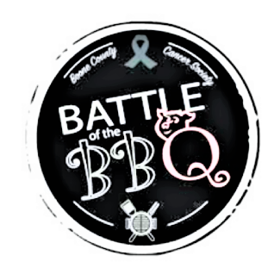
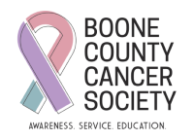

Boone County Cancer Society: Serving Our Community

About Boone County Cancer Society (BCCS)
The Boone County Cancer Society is dedicated to supporting cancer patients who live in Boone County. Our organization operates with two part-time staff members, a committed board, passionate volunteers, and through ongoing local fundraising efforts. We offer a variety of services, support groups, and educational programs aimed at meeting the needs of our community.
At BCCS, we understand that every patient's situation is unique. We treat everyone with compassion, working one-on-one to provide personalized care. Importantly, all funds raised by BCCS stay within Boone County, directly benefiting our local patients. We are an independent organization, unaffiliated with and not funded by the American Cancer Society.

How We Serve Boone County
In 2025, BCCS assisted more than 100 patients, distributing over $100,000 in direct services to residents of Boone County. Every patient receives $1,500 in financial assistance, which can be used for transportation, medical bills, prescriptions, or any expenses related to their cancer diagnosis.
- You’re Not Alone: Comfort kits are provided to patients undergoing chemotherapy and radiation, offering support during treatment.
- Annual Scholarship: BCCS awards a scholarship to a senior from each Boone County school who is pursuing a career in the medical field.
- Wigs and Bras Program: We supply wigs and bras to patients in need.
- Additional Services: We offer various other services based on the needs of our patients.

How You Can Help
To continue offering these free services, BCCS relies on the generosity of our community. We invite you to consider sponsoring the 2026 Battle of the BBQ, our largest annual fundraiser. Your tax-deductible sponsorship (Boone County Cancer Society is a 501(c)3 organization, ID 35-6044450) will help ease the financial burden for local cancer patients as they fight this difficult disease.
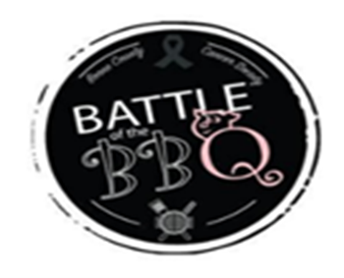

2026 Sponsorship Opportunities

Sponsorship  Benefits | Grill Master  $10,000 | King of the Grill  $5,000 | Pit  Boss  $2,500 | The Sauce  Club  $1,000 | Pulled Pork  Club  $500 | Licensed to Grill  $250 or less
Logo/Name on banner and printed material | 
Strategic acknowledgements throughout the day’s event
Logo/Name on back of event shirt
Personal Banner at the event (if provided)
Acknowledgement on our BCCS Facebook page
Logo/Name on FRONT of event shirt
Event T-shirts provided | 8 | 6 | 4 | 2
Event Wristbands provided | 16 | 12 | 8 | 4
Save The Date!
August 8th, 2026 - 5-7pm
The Battle of the BBQ Contribution Agreement

Boone County Cancer Society (BCCS) Responsibilities
BCCS will plan, organize, promote, and evaluate the event. BCCS will acknowledge the Event Sponsor per the advertised sponsorship levels and follow the sponsor’s rules and guidelines.

Needed from Sponsor
- Funds upon signing agreement
- High Resolution Logo/Imagery
- Authorized Signature
- Battle of the BBQ Contribution Agreement Form

*BCCS reserves the right to select and give final approval*

Company Name:
Contact Name:
Mailing Address:
City, State, Zip:
Email:
Website:
Phone:
Signature:
Printed:
Contribution Level (Circle one):
Grill Master King of the Grill Pit Boss
The Sauce Club Pulled Pork Club Licensed to Grill

Sponsorship Payment of: $____________

Credit Card: AMEX MasterCard Visa Discover
Credit Card Number:
Exp. Date: 3 Digit Code:
OR
Check Number (please make all checks payable to Boone County Cancer Society (501c3):
Contact
To become a Battle of the BBQ Sponsor, send this Sponsorship Agreement and payment by July 17th, 2026, via email or mail. Any Sponsors that submit after this date may not be on printed material and/or t-shirts. If you have questions about other promotional sponsorship opportunities, contact Joy at (765) 336-9119.

